**Initial analysis: regressing stock returns on the Global Health Security Index (Overall Score)**

**Dataset**

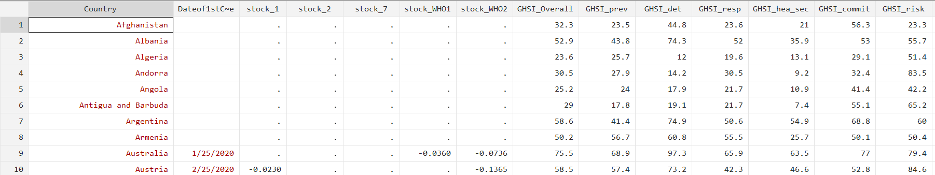

Currently have stock data for N = 24 (but missing 6 values for stock_1).

* 10 European Countries (inc. Russia)
* 9 Asian Countries (inc. Israel)
* 2 North America, 2 South America + Australia.
  + *Countries are based on Investing.com’s main national indices list.*

**Definitions:**

stock_1: % change in domestic stock index on the day the first coronavirus case was reported in that country.

* stock_2 and stock_7: same, but day after/average of values over the following week.

stock_WHO1: % change in domestic stock index on the day following the WHO’s classification of COVID-19 as a pandemic (11th March 2020).

* stock_WHO2: same, but 12th March 2020.

GHSI_Overall: overall Global Health Security Index rating out of 100 (higher score implies better security).

* Amalgamation of several submeasures (prevention, response, detection etc), which constitute the other variables.

**Scatterplots**



stock_WHO2 and GHSI_Overall

stock_1 and GHSI_Overall

Initially, looks like more of a negative correlation with stock_WHO2 – more prepared countries have a greater negative shock to domestic stock index.

* In the data, it seemed like markets hadn’t adjusted within a day (as we can see, many of the stock_1 values are positive, implying the market didn’t fall on the day of the first coronavirus case.
  + In contrast, all indices fell on the day *after* the WHO announcement.

**Regression Results**

$$stock{_1}_{i}=α+βGHSI_{i}+u_{i}$$

|  |  |  |  |  |  |  |  |  |  |  |
| --- | --- | --- | --- | --- | --- | --- | --- | --- | --- | --- |
| stock_1 | Coef. | | St.Err. | t-value | | p-value | [95% Conf | | Interval] | |
| GHSI_Overall | 0.00003 | | 0.0003 | 0.10 | | .919 | -.001 | | .001 | |
| Constant | -.009 | | .019 | -0.48 | | .641 | -.05 | | .032 | |
| Mean dependent var | | -0.007 | | | SD dependent var | | | 0.022 | |
| R-squared | | 0.000 | | | Number of obs | | | 18.000 | |
| F-test | | 0.011 | | | Prob > F | | | 0.919 | |

|  |  |  |  |  |  |  |  |  |  |  |
| --- | --- | --- | --- | --- | --- | --- | --- | --- | --- | --- |
| stock_WHO2 | Coef. | | St.Err. | t-value | | p-value | [95% Conf | | Interval] | |
| GHSI_Overall | -.00159*** | | .0005 | -2.95 | | .007 | -.003 | | 0 | |
| Constant | .01 | | .035 | 0.29 | | .771 | -.063 | | .084 | |
| Mean dependent var | | -0.088 | | | SD dependent var | | | 0.039 | |
| R-squared | | 0.198 | | | Number of obs | | | 24.000 | |
| F-test | | 8.714 | | | Prob > F | | | 0.007 | |

**Discussion**

1st regression: results are insignificant. No effect of pandemic preparedness on day 1 stock returns. Potentially because:

* Measurement error: reported vs confirmed cases, website’s information may be incorrect.
* **Markets don’t have time to adjust.**
  + Observationally, stock_WHO2 had greater absolute values than stock_WHO1: perhaps markets need a day to incorporate information.

2nd regression: $β$ is negative and highly significant.

* Marginal increase in the GHSI increased the size of the negative shock by 0.159%. **Opposite of what we would expect!** Why?
  + OVB: need to incorporate GDP/capita etc (richer economies may have more responsive stock markets (which react more to any shocks) and systematically spend more on preparedness
  + Sampling bias – clearly not a representative sample.